Experiment #1 – Spectrum Analysis

# Youssef Samwel

# [yo800238@ucf.edu](mailto:yo800238@ucf.edu)

# EEE3352 Signal Analysis and Analog Communications

# Due Date 9/19/2023

# **Project Description**

# The students were assigned the task of generating a sinusoidal signal using the function generator (Tektronix AFG3022) and then accurately measuring this signal using an oscilloscope. As part of this assignment, students were required to meticulously record the waveform and subsequently perform a Fast Fourier Transform (FFT) analysis on the signal using the oscilloscope.

# **2.0 About Laboratory Day**

# The laboratory session took place on the Tuesday section between 9:00am and 11:50am on September 12, 2023. Regrettably, my lab partner was unable to attend the session, which meant I had to conduct the experiment independently.

# **3.0 Pre-laboratory Questions**

# a. Calculate the amplitude in dBV of a 4 KHz, 2 volt peak-to-peak, sine wave.

$$V_{signal}=\frac{V_{pp}}{\sqrt{2}}=\frac{2}{\sqrt{2}}=\sqrt{2}$$

$$dBV=20\log\left(\frac{V_{signal}}{V_{ref}}\right);V_{ref}=1.0 V$$

$$dBV=20\log\left(\frac{\sqrt{2}}{1}\right)≈3.01$$

# b. Calculate the peak-to-peak voltage of a −10 dBV, 4 KHz, sine wave.

$$dBV=20\log\left(\frac{V_{signal}}{V_{ref}}\right);V_{ref}=1.0 V$$

$-10=20\log\left(\frac{V_{signal}}{1}\right)→{=V_{signal}=10}^{-\frac{10}{20}}≈0.316 V$

# **4.0 Experiment Procedure**

The first step entailed configuring the function generator to produce a 4 kHz signal with a 2-volt peak-to-peak amplitude. A crucial detail to emphasize is that the function generator had to be set to a 50-ohm impedance to prevent undesirable signal reflections. Failing to do so would have resulted in unintended alterations to the phase and magnitude of the signal during subsequent FFT measurements. Afterwards, we began our measurements with the oscilloscope by connecting the Channel 1 probes to the function generator probes. To setup up measurements on the oscilloscope when pressed the “Preset” button and the “Auto set” button and adjusted the trigger level. The following is the measured signal by the oscilloscope.

Following this, we initiated our measurements on the oscilloscope by connecting the Channel 1 probes to the function generator's probes. To configure the oscilloscope for measurements, we pressed both the "Preset" and "Auto Set" buttons and then fine-tuned the trigger level as needed. Below, you can observe the signal as measured by the oscilloscope.

4 kHz Waveform on Oscilloscope

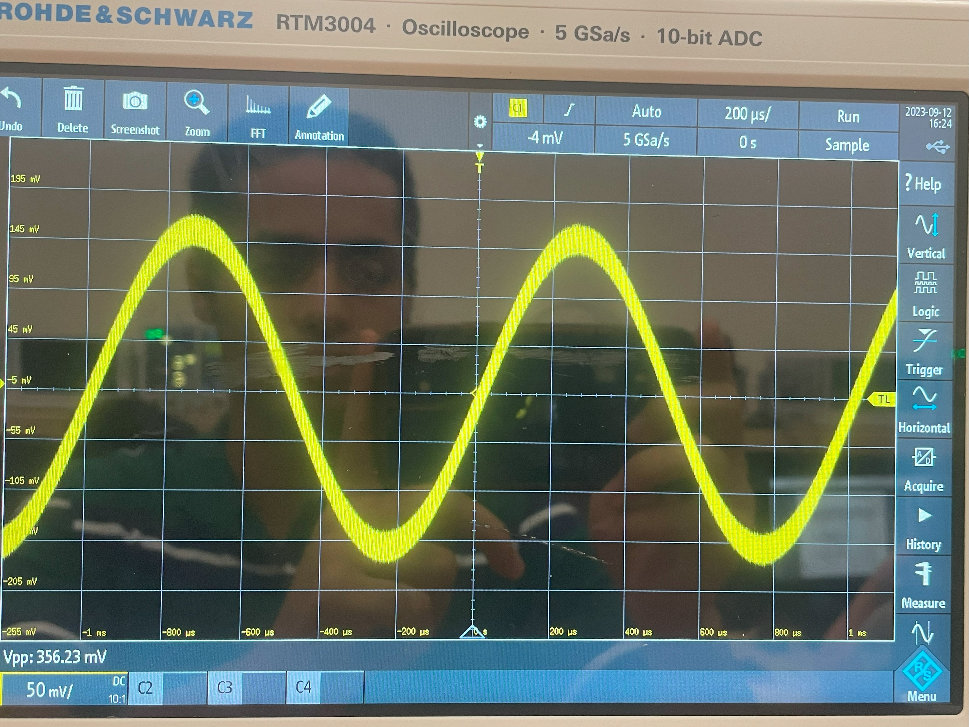

The subsequent step involved performing the Fast-Fourier Transform on the oscilloscope measurement. To accomplish this, we clicked on the FFT button and adjusted the FFT parameters accordingly. Initially, we configured the horizontal time scale to display 10 cycles, a task achieved through the following method.

$$P=\frac{1}{f}=\frac{1}{4 kHz}=0.00025→10 cycles=10*P= 2.5 ms$$

According to the lab manual, we were instructed to set up the following configuration.

1. FFT Source to channel 1 (function generator)
2. FFT Window to hanning
3. Vertical Scale to dBV RMS
4. Automatic RBW to off

The following were the parameters for the FFT computation.

1. Start: 0 Hz
2. Stop: 8 kHz
3. Center: 4 kHz
4. RBW: 120 Hz
5. W: 12 ms
6. P: 0 s

To measure the peak value of the FFT waveform we moved the cursors to the peak to get a better reading. The following is our measurement.

FFT on 4 kHz Signal

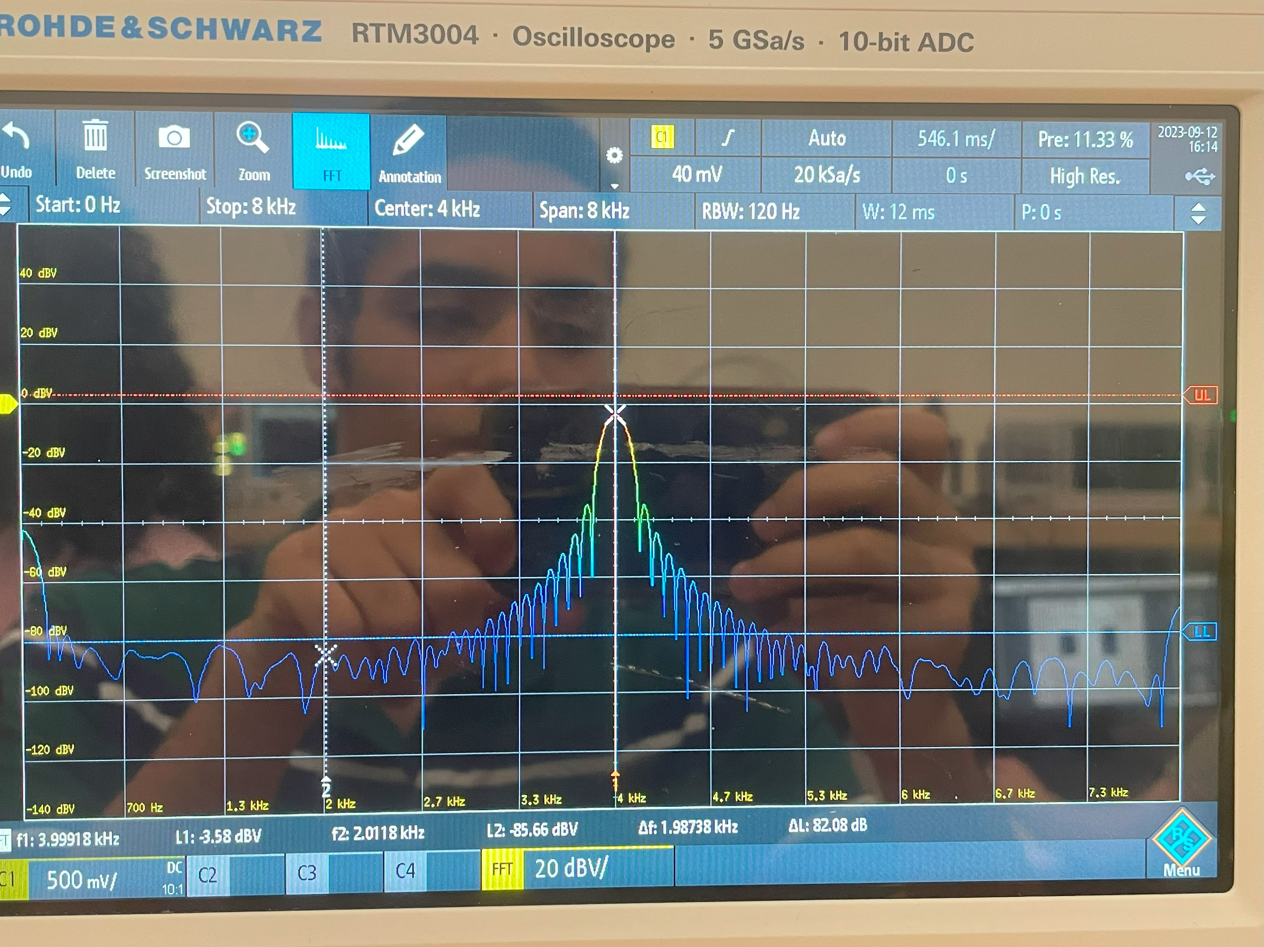

After measuring the 4 kHz signal, we were instructed to change the frequency of the generated signal to 2 kHz and redo the measurements. The following is our result for the 2 kHz signal.

FFT on 2 kHz Signal

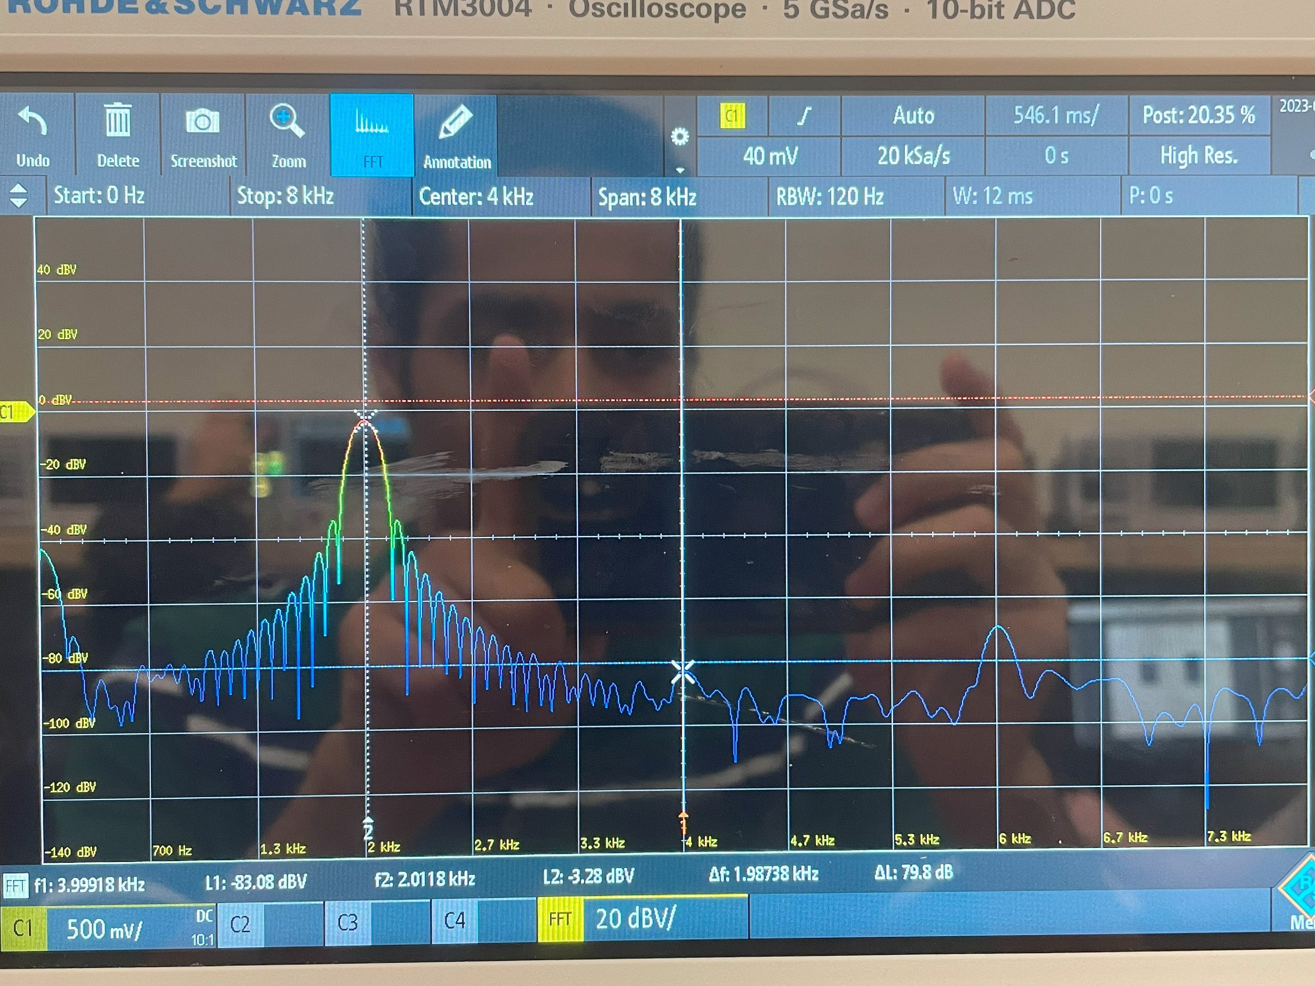

# **5.0 Observations**

During the laboratory experiment, several key observations were made. Initially, when the function generator was configured to produce a 4 kHz sinusoidal signal with a 2-volt peak-to-peak amplitude, the oscilloscope displayed a well-defined and stable waveform. The signal appeared to exhibit the expected characteristics of a sinusoidal waveform, with smooth oscillations between peaks and troughs.

Upon performing the Fast Fourier Transform (FFT) analysis on the 4 kHz signal, the resulting FFT waveform displayed a distinct peak at the center frequency of 4 kHz. This peak corresponded to the dominant frequency component of the signal, confirming that the function generator successfully generated the intended frequency. The FFT analysis also provided valuable insight into the signal's frequency spectrum and amplitude distribution.

Subsequently, when the frequency of the generated signal was changed to 2 kHz, a new measurement was conducted. The oscilloscope displayed a waveform with a lower frequency, in line with the altered signal parameters. The FFT analysis of the 2 kHz signal revealed a distinct peak at the center frequency of 2 kHz, corroborating the frequency change.

In summary, the observations in the laboratory experiment affirmed the successful generation and measurement of sinusoidal signals, showcasing the importance of precise instrument calibration and FFT analysis in characterizing signal properties.

# **6.0 Learned Objectives**

* Use of function generator
* Measurement using oscilloscope and practical probing.
* Simulation via LT-spice
* FFT Analysis
* Frequency Domain
* Data Comparison

# **7.0 Conclusion**

In conclusion, the laboratory experiment aimed to explore the generation and measurement of sinusoidal signals using a Tektronix AFG3022 function generator and an oscilloscope. Several key findings and takeaways emerged from this experiment.

Firstly, through the meticulous configuration of the function generator, we successfully generated a 4 kHz sinusoidal signal with a 2-volt peak-to-peak amplitude. This initial step underscored the significance of precise instrument setup, including considerations of impedance to prevent signal reflections that could distort measurements.

The subsequent measurement phase on the oscilloscope revealed clear and stable waveforms for both the 4 kHz and 2 kHz signals. Visual observations of the waveforms confirmed the expected characteristics of sinusoidal signals, including smooth oscillations between peaks and troughs.

The implementation of Fast Fourier Transform (FFT) analysis was a crucial aspect of this experiment. The FFT analysis allowed us to delve deeper into the frequency spectrum of the signals. In doing so, we verified that the dominant frequencies corresponded precisely to the set frequencies of 4 kHz and 2 kHz. This confirmed the accuracy of the signal generation process and the effectiveness of our measurements.

Furthermore, the comparison between the two frequencies highlighted the direct relationship between signal parameters and their visual representation on the oscilloscope and in the frequency spectrum. Lowering the frequency from 4 kHz to 2 kHz resulted in a corresponding shift in both the waveform and the dominant frequency in the FFT analysis.

In summary, this laboratory experiment provided valuable hands-on experience in signal generation, oscilloscope operation, and FFT analysis. It reinforced the importance of meticulous instrument setup, calibration, and the interpretation of measurement results. These skills are fundamental in various fields, including electronics, communications, and signal processing, underscoring the practical relevance of the knowledge gained in this experiment. Overall, the experiment was a successful exploration of signal characteristics and their analysis, contributing to a deeper understanding of fundamental principles in electrical engineering and measurement.